Scholarship Appeal
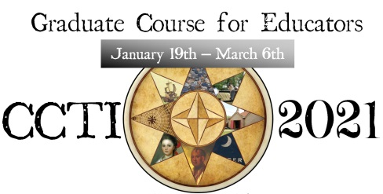
Please note that scholarship recipients must be full-time employed certified educators.
Please submit to Director@ExploreColonialSC.org by December 20, 2020
Name: School of Employment:
Email: Personal Phone Number:
Please respond to the following questions so that it represents you as an educator.
- What content area(s) do you currently teach? How many different students are you typically responsible for educating each academic year (e.g., 2 classes/50 students)?

- Why do you have an interest in the Colonial Charleston Teacher Institute?

- How do you intend to implement the knowledge you gain from this graduate course?

- Upon the conclusion of this course, how might you relay useful ideas to colleagues within your teaching community?

- Do you feel that the method in which history is taught matters? Why?

By submitting this application you agree that, if awarded this scholarship, you are willing to attend the Colonial Charleston Teacher Institute hosted January 19 – March 6, 2021.

___________________________________
CCTI Scholarship Candidate Signature:

_____________
Date

Kindly email to Director@ExploreColonialSC.org by December 20, 2020

