Colonial Charleston Teacher Institute: 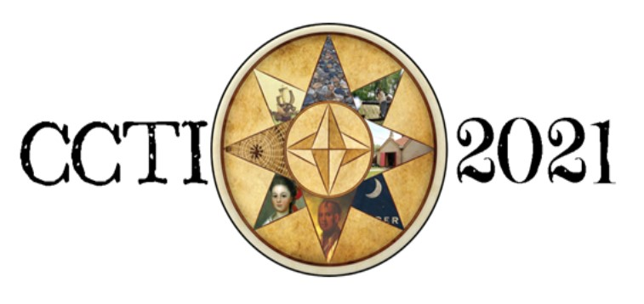
A Graduate Course for Educators
September 20 - November 19, 2022
Scholarship Appeal
Please note that scholarship recipients must be full-time employed certified educators.

Instructions:
Fill out this application and submit to the National Society of the Colonial Dames of America in the State of South Carolina (NSCDA-SC) at scdames81@gmail.com between May 15 and September 6, 2022. Be sure to apply EARLY as a sizeable but finite number of scholarships will be awarded by the NSCDA-SC for this fall.

Scholarship winners will have all tuition costs covered by the NSCDA-SC except for the $150 non-refundable deposit. This includes admission to 10 historical sites!

Name: |  | School of Employment:
Email: |  | Phone Number:

Please respond to the following questions so that it represents you as an educator.
- What content area(s) do you currently teach? How many different students are you typically responsible for educating each academic year (e.g., 2 classes/50 students)?

- Why do you have an interest in the Colonial Charleston Teacher Institute?

- How do you intend to implement the knowledge you gain from this graduate course?

- Upon the conclusion of this course, how might you relay useful ideas to colleagues within your teaching community?

- Do you feel that the method in which history is taught matters? Why?

By submitting this application, you agree that, if awarded this scholarship, you will attend the Colonial Charleston Teacher Institute hosted September 20 to November 19, 2022

CCTI Scholarship Candidate Signature

Date

Kindly fill out and return by email to NSCDA-SC at scdames81@gmail.com
between May 15 and September 6, 2022

