Colonial Charleston Teacher Institute: 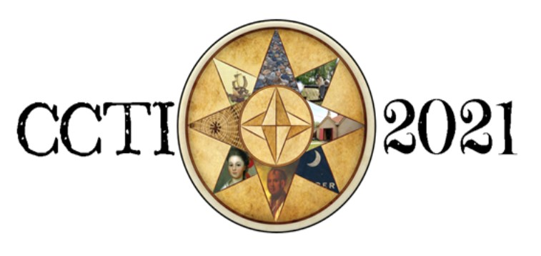
A Graduate Course for Educators
September 21- November 6, 2021
Scholarship Appeal
Please note that scholarship recipients must be full-time employed certified educators.

Instructions:
Fill out this application and submit to rennieall52@gmail.com between June 1 and September 10, 2021. Be sure to apply EARLY as a sizeable but finite number of scholarships will be awarded by the National Society of the Colonial Dames of America in the State of South Carolina (NSCDA-SC) for this fall.

Scholarship winners will have all tuition costs covered by NSCDA-SC except for the $150 non-refundable deposit. This includes admission to 10 historical sites!

Name School of Employment:

Email: Personal Phone Number:

Please respond to the following questions so that it represents you as an educator.
- What content area(s) do you currently teach? How many different students are you typically responsible for educating each academic year (e.g., 2 classes/50 students)?

- Why do you have an interest in the Colonial Charleston Teacher Institute?

- How do you intend to implement the knowledge you gain from this graduate course?

- Upon the conclusion of this course, how might you relay useful ideas to colleagues within your teaching community?

- Do you feel that the method in which history is taught matters? Why?

By submitting this application, you agree that, if awarded this scholarship, you will attend the Colonial Charleston Teacher Institute hosted September 21 to November 6, 2021

CCTI Scholarship Candidate Signature:

Date

Kindly fill out and return by email to rennieall52@gmail.com
between June 1 and September 10, 2021

